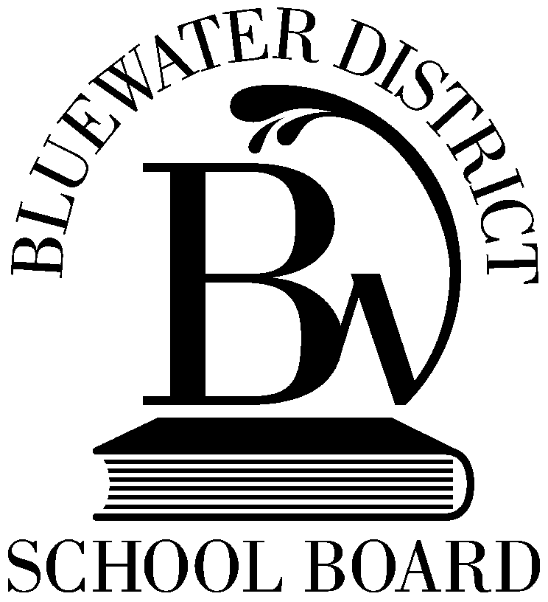
AF 7130
Bluewater District School Board
351 1st Ave. N., Box 190, Chesley, Ontario N0G 1L0 (519) 363-2014 or 1-800-661-7509 Fax (519) 370-2909

ANNUAL LEARNING PLAN

Year of Performance Appraisal Cycle: Year 1 Year 2 Year 3 Year 4 Year 5

Performance Goals | Learning and Development

Supervisor Comments | Employee Comments

 | Employee’s Name |  |  |  |  |  | Date: |  |  | Employee’s Signature
 | Supervisor’s Name |  |  |  |  |  | Date: |  |  | Supervisor’s Signature
 | Distribution: | Copy - Employee |  |  | Copy - Lead Supervisor | In Appraisal year – Original - Executive Officer Human Resources Services (for Personnel File)
 | (E-Template 2016.05.25) Page 1 of

